Resume – Linda Ryan
Collections Cont’d
Collins, Charleston, NC; Mark Everheart, London, England; Ashley McCrady, San Diego, CA; Dane Stark, Page Mill Winery, Livermore; Marty Ferguson, Ashland, OR; Len and Francoise Alexander, Santa Fe, NM; Doug and Debbie Weiland, Milpitas, CA; Don Meeker & Diana Carey, Livermore, CA; Marjorie McMahan, Livermore, CA; Mr. & Mrs. T.J. Tyler, Livermore, CA; Walter & Nan Davies, Livermore, CA; Gordon & Jane Ayotte, Livermore, CA; Robert Gundry, Marketing Director, Wente Vineyards

Select Solo Exhibitions (CA)
2015 Parallax Art Fair, London, England
2014 Flow, Solo Exhibition, Wente Vineyards, Livermore
2012 Body of Movement, Cuda Ridge, Livermore
2007 Abstract Figuratives, art!space gallery, Livermore
2005 Explorations, Art of Presentation Gallery, Pleasanton
2004 Harvest Dance, Wente Vineyards, Livermore
2003 Join the Dance, Robert Butler Art Gallery, Danville

Select Group Exhibits
2015 Art Wynwood Group Opening Exhibition, Miami
2015 “Talent Plus” at Las Lagunas Gallery, Laguna
Beach
2015 Art San Diego Contemporary Art Fair, San Diego
2015 Parallax Art Fair, London, England

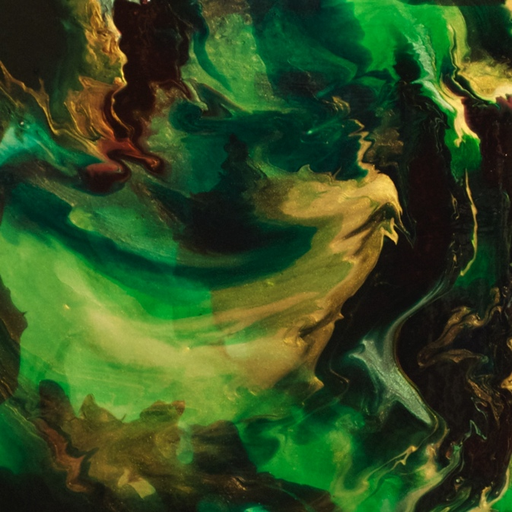

Time 4.0, 12x12, Acrylic & Pouring Medium

www.lindaryanfineart.com

___________________________________________

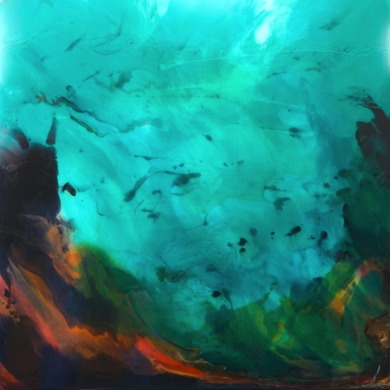
Dreams of the Reef at Dawn
24x24 Acrylic & Pouring Medium
Related Education
Studied at length with Robert Steiner, Nationally Acclaimed Duck Stamp Artist, and extensively with Bill Paskewitz at Las Positas College, Livermore, CA.

Select Honors and Awards
2014 Arts Leadership Award, Alameda County Arts Commission, Oakland, CA
2001 $10,000 Robert Butler Award, Robert Butler Gallery , Danville, CA
2000 $1,000 PAL, First Place Scholarship Award, Pleasanton, CA

Select Commissions
Livermore Mayor John Marchand and Mrs. Marchand; Livermore Councilwoman Lorraine Dietrich; Page Mill Winery; Tesla Vintners, Murrietta's Well Winery; Stephanie Bugbee, Danville, CA; The Wood Family Vineyards; Valley Community Bank; Francoise Boussett-Alexander; Doug and Debbie Weiland, Milpitas; Lisa Weyland, Piedmont; Lee and Maureen McLemore, San Ramon; Gabriel & Cindy Duffin, Livermore

Select Collections
Cindy Douglas, Stonehaven, Scotland; Bradley Gersich, Esq., Pleasanton, CA; Tenuta Vineyards, Livermore, CA; John and Janet Williams, San Francisco/Connecticut; Dennis Hare, Mentone, CA; Debbie Chadwick, Kent, England; Grant Anderson, Phoenix, AZ; Robert Butler, Danville, CA; David

